Name: ____________________________________________ Date: ____________________________________

**AI or NOT?**

**Instructions**:

Read each example and decide if the device or program uses AI. Put a checkmark or X on the correct answer for each question.

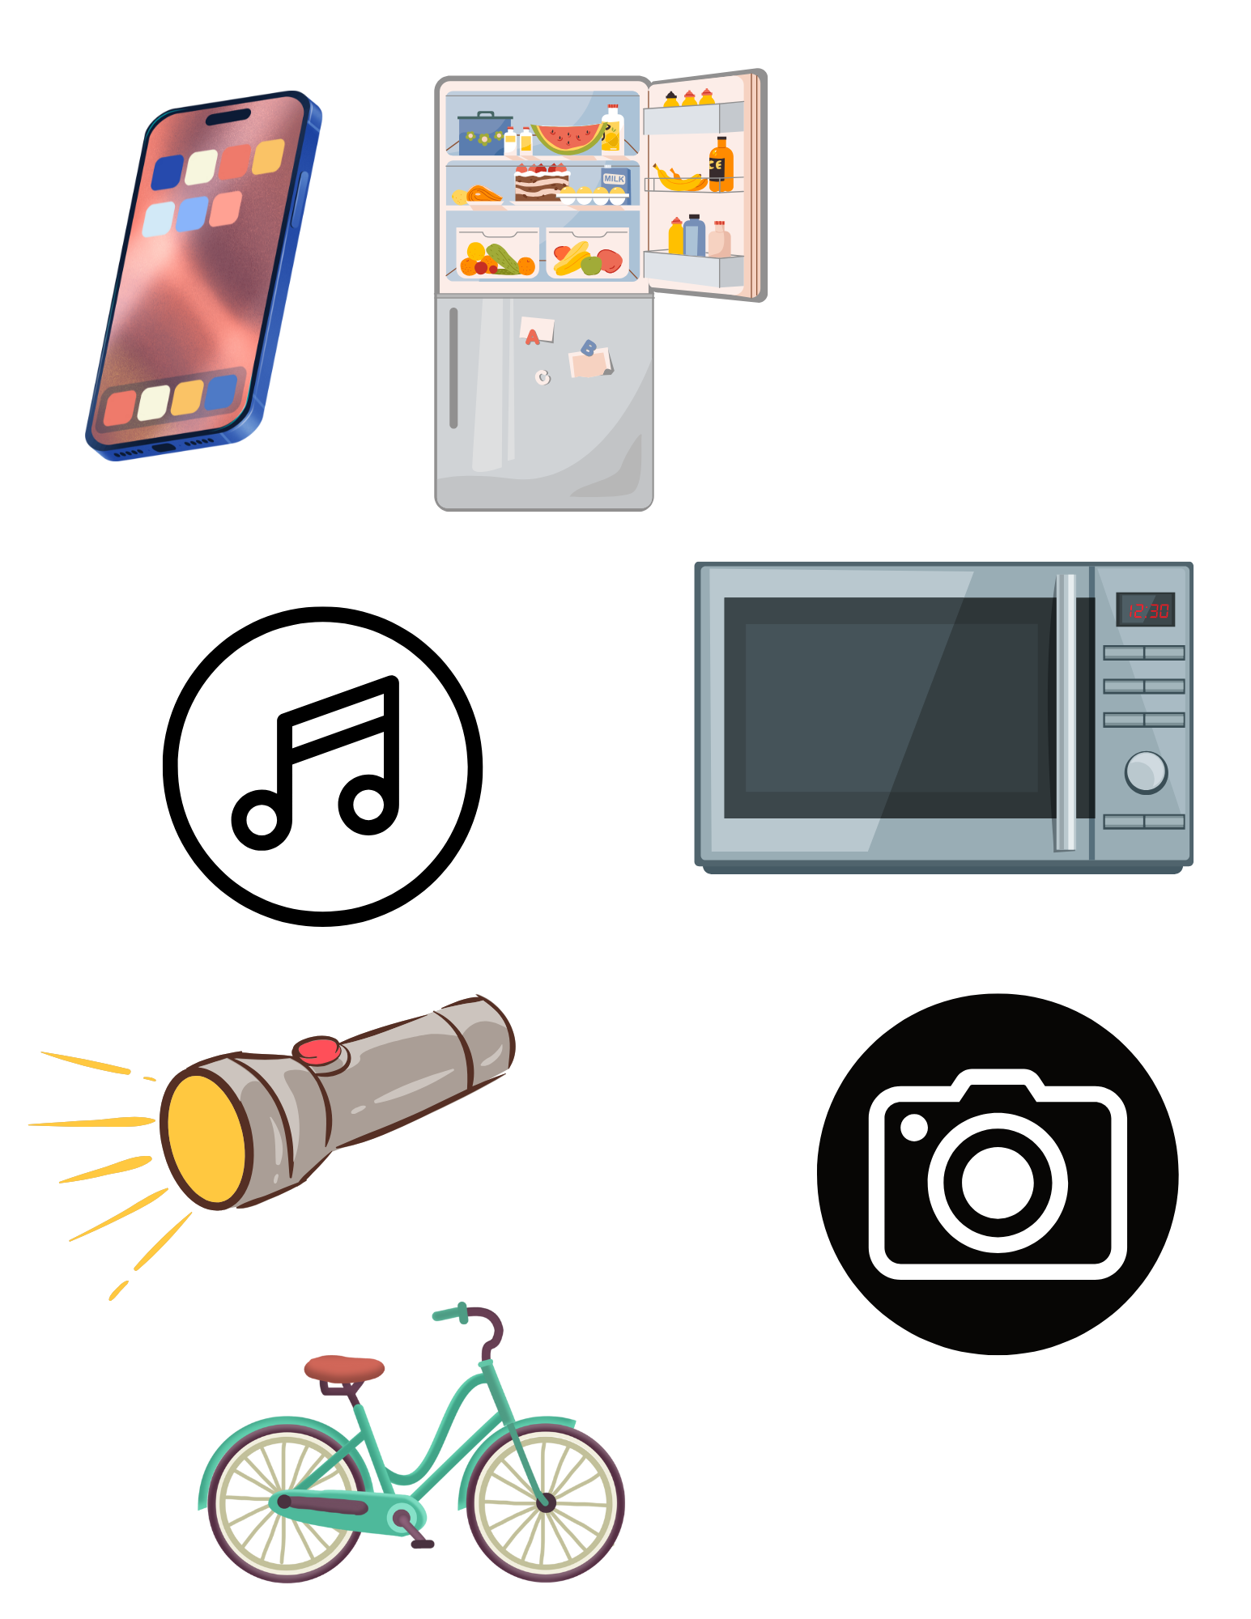

|  |  |  |
| --- | --- | --- |
| 1. A smartphone that suggests apps based on the ones you use most often.  Yes ____ No ____ | 2. A refrigerator that keeps food cold and makes ice cubes.  Yes ____ No ____ | 3. An app that learns what music you like and suggests new songs.  Yes ____ No ____ |
| 4. A flashlight that turns on when you press a button.    Yes ____ No ____ | 5. A microwave that heats food for a set amount of time when you press start.  Yes ____ No ____ | 6. A camera app that automatically suggests the best filter for a photo based on lighting.  Yes ____ No ____ |
| 7. A bicycle with gears that you change manually to make pedaling easier or harder.  Yes ____ No ____ | 8. An app that turns on lights in your house when it senses you are nearby.  Yes ____ No ____ | 9. A weather app that shows the hourly forecast.  Yes ____ No ____ |

Extension:

Choose one of your answers. Explain why the device is AI or not AI.

ANSWER KEY

1. **A smartphone that suggests apps based on the ones you use most often.**

* **Yes (✓)** – AI (Uses machine learning to predict and suggest apps based on user behavior.)

1. **A refrigerator that keeps food cold and makes ice cubes.**

* **No (X)** – Not AI (Performs a mechanical function without learning or decision-making.)

1. **An app that learns what music you like and suggests new songs.**

* **Yes (✓)** – AI (Uses algorithms and machine learning to analyze listening history and recommend music.)

1. **A flashlight that turns on when you press a button.**

* **No (X)** – Not AI (Simply follows direct user input without learning or adapting.)

1. **A microwave that heats food for a set amount of time when you press start.**

* **No (X)** – Not AI (Executes a programmed function without decision-making or learning.)

1. **A camera app that automatically suggests the best filter for a photo based on lighting.**

* **Yes (✓)** – AI (Uses computer vision and AI algorithms to analyze lighting and suggest appropriate filters.)

1. **A bicycle with gears that you change manually to make pedaling easier or harder.**

* **No (X)** – Not AI (User controls the gears manually; no intelligence or learning is involved.)

1. **An app that turns on lights in your house when it senses you are nearby.**

* **Yes (✓)** – AI (Uses sensors and possibly predictive learning to automate lighting based on presence detection.)

1. **A weather app that shows today’s forecast without learning your preferences.**

* **No (X)** – Not AI (Displays static weather information without personalization or learning.)